**STATEMENT OF ENVIRONMENTAL EFFECTS**

**PROJECT ADDRESS COUNCIL CLIENT DATE**

**Dual occupancy and removal of existing residence 2 Brockman Ave, NSW 2212 (LOT 1049, DP 31413)**

**Canterbury-Bankstown council Mr Tarek Noun & Mr Ribal Noun 08th Febuary 2025**



**Engineer**

**Tarek Noun**

**2 Brockman Ave, NSW 2212**

**Telephone: 0411 275 275 Email:** [**ribalnoun@gmail.com**](mailto:ribalnoun@gmail.com)

# INTRODUCTION

On behalf of our client and developer of the project above, we hereby lodge a development application and this Statement of Environmental Effects for the proposed dual occupancy and this Statement of Environmental Effects describes the site, its environs, the proposed development, and provides an assessment of the environmental impacts and identifies the steps to be taken to protect or reduce the potential impacts on the environment.

The DA seeks to approve the construction of a Dual occupany and the removal of the existing single storey existing weatherboard house with tile roof. The proposal intends to remain compatible with the established building forms in the immediate locality. Design and layout of the development envelope proposed aims to maintain the objective of the current development control plan.

This report describes the site, surrounding properties, proposed development,

provides background information and justifies the proposed development on the subject site. All work carried out on site are to comply with all the requirements of the

National Construction Code (NCC), relevant Australian Standards and CB City Council’s regulations. Any environmental concerns not covered directly in this document or which arise during construction will be handled in an appropriate fashion, to minimise environmental concerns.

# THE SITE CONDITIONS / STREETSCAPE

This SEE report has been prepared in support of a development application (DA) to Canterbury Bankstown City Council with regards to the land at No. **2 Brockman Ave, NSW 2212** . Pursuant to Canterbury-Bankstown Local Environmental Plan 2023 and Canterbury-Bankstown Development Control Plan 2023- Chapter 5 Residential Accommodation 5.1 Former Bankstown LGA Section 4 the site is currently zoned Residential 2 – Low Density Residential and the proposed use is permissible with consent.

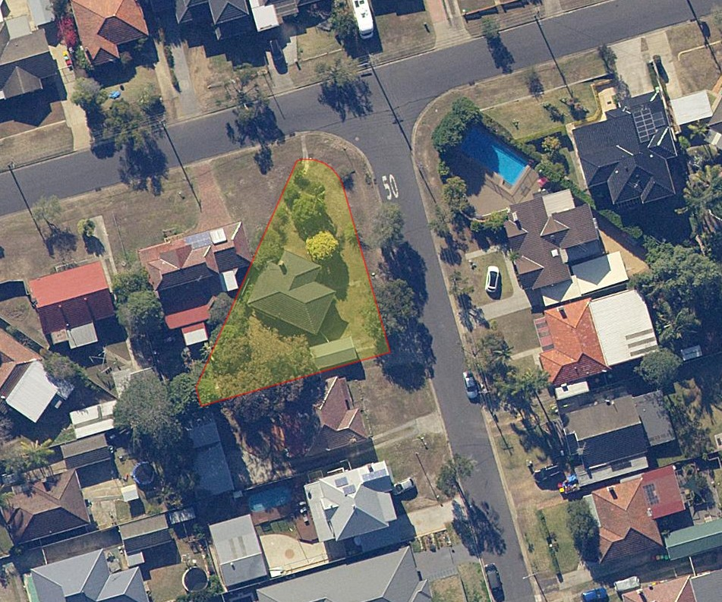Location – Aerial map

Source: SIX Maps

The site situated on Brockman Ave is the subject of this application. The property is zoned Residential R2, and the property is existing with adjoining neighbours on the western, and southern side. Brockman ave is on the north east side of the property and Rowell St on the north west side.

The site is of irregular shape, measuring 32.00 m x 43.46m x 27.96m having a total area of

680.1 m2; and has a fall 2.9 m from the rear of the property to the front.

The property is known **(Lot 1049, DP 31413)** –**2 Brockman Ave, NSW 2212**

The north-east of the property is Brockman Ave; the south-east side neighbor is a single weatherboard house with tile roof (no. 4) and north-west side neighbor is a fibro house with tile roof (no. 19 Rowell St).

Our application pertains to one allotment of land. The site currently enjoys sufficient public transport, and is in close proximity to schools and several public parks.

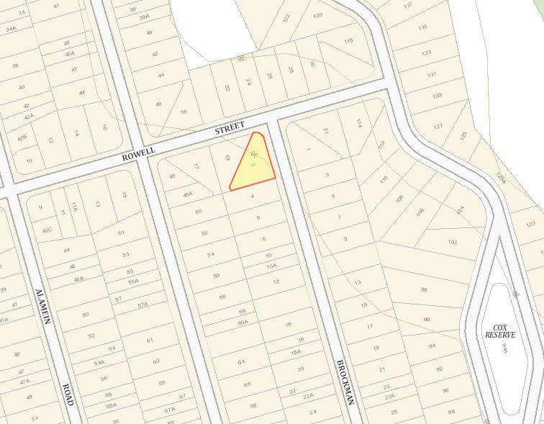

Location – site map

Source: SIX maps

# THE PROPOSAL

Our proposed design is in keeping with the Development Control Plan and is well adapted to the future development.

The proposal involves the construction of a dual occupancy and the removal of the existing single storey existing weatherboard house with tile roof

The proposed development is a dual occupancy double brick first floor, brick veneer second floor dwellings with tile roofs. The side setbacks are complying with councils’ policy. Each proposed dwellings consists of 4 bedrooms, two bath, one ensuite, living and kitchen/ dining. The design is well articulated, therefore minimizing the bulk and scale of the proposed development. Materials finish such as face brickwork and concrete roof tiles will complement the existing dwellings in the area.

The overall appearance of our proposal is comparable to other developments in the locality. The well-articulated façade incorporates architectural design elements which will strengthen the streetscape and the relationship between future dwellings.

The areas of the proposed development are as follows

Site area Dwelling One Dwelling Two Total area

FSR (336.30/680.10 m²)

680.1m²

172.31 m²

163.99m²

336.30 m²

0.5:1

Table 1

|  |  |  |  |
| --- | --- | --- | --- |
| Compliance with the relevant DCP is summarized in the following table: - Issue | Council | Proposed | Comment |
| Requirements (Min) | | | |
| Dwelling 1 | | | |
| Front Setback (m) Ground Floor | 5.5m | 5.5m | Complies |
| Front Setback (m) First Floor | 6.5m | 6.5 m | Complies |
| Side Setback (m) | 0.9m | 2.135m | Complies |
| Rear Setback (m) | 3.54m (0.6 x 5.9m) | 9m – 15m | Complies |
| P.O.S | 80m2 | 150.72 m2 | Complies |
| Site Coverage | Max 50% -  345.63 m2 | 49% -  172.31 m2 | Complies |
| Landscape | Min 45% front setback- | 65%  41.25 m2 | Complies |
| Max Wall Height | 7.0m | 5.9m- 6.4M | Complies |
| Solar Access | Sitting to maximise solar access | Solar access maximized | Complies |

6

|  |  |  |  |
| --- | --- | --- | --- |
| Compliance with the relevant DCP is summarized in the following table: - Issue | Council | Proposed | Comment |
| Requirements (Min) | | | |
| Dwelling 2 | | | |
| Front Setback (m)  Ground Floor | 5.5m | 5.5m | Complies |
| Front Setback (m) First Floor | 6.5m | 6.5 m | Complies |
| Side Setback (m) | 0.9m | 1.8m | Complies |
| Rear Setback (m) | 3.54m (0.6 x 5.9m) | 5.5m – 10.00m | Complies |
| P.O.S | 80m2 | 90 m2 | Complies |
| Site Coverage | Max 50% -  334.48 m2 | 49% -  163.99 m2 | Complies |
| Landscape | Min 45% front setback- | 65%  41.25 m2 | Complies |
| Max Wall Height | 7.0m | 5.9 - 7m | Complies |
| Solar Access | Sitting to maximise solar access | Solar access maximized | Complies |

# IMPACT OF THE DEVELOPMENT

The proposal has no social or economic impact on the locality.

The proposed façade will have a minimum impact on the streetscape due to being located at the rear of the site. Together with the proposed landscape plan, the proposal will enhance the future streetscape and landscape character of the residential neighborhood.

The slab on ground construction will result in minimal disturbance to the natural slope of the land. Stormwater will be connected and discharged to existing council kerb outlet, which satisfies council requirements.

# PRIVACY, VIEWS AND OVERSHADOWING

The proposed dwellings double story finish floor level of 3m height and max height of 5.9m

The proposal will receive the minimum six hours of sunlight to its private open space.

# DENSITY/ SETBACKS

As per the above table 1 the proposed development complies with the DCP and will cause minimum impact.

Land Zoning -R2

# SUITABILITY OF THE DWELLING

The proposed secondary dwelling is consistent with character required for the development. The setback and window placement ensures no negative effect on future adjoining sites and solar access is not compromised.

# LANDSCAPING

The principal dwelling has been provided with sufficient private open space which is demonstrated on the plan having a courtyard area of dwelling one 175.2m2 dwelling two 163.99m2 and both comply with the POS requirements.

# STORMWATER DRAINAGE & CONTROL

Stormwater will be collected and drained to the Council’s stormwater system using the existing stormwater system through a kerb line connection.

# SITE VEGETATION | PARKING

Parking for both dwellings will be accessed via Brockman Ave. No street trees are proposed to be removed or relocated.

For Proposed Removed and pruned site trees see Arborist report.

# CONCLUSION

It is considered that the current strategy of Canterbury Bankstown Council to promote a variety of housing choice in the locality is being achieved by the development. Council’s DCP requirements and good planning principles have been incorporated in the design, which has resulted in a quality development that will enhance the locality. Consideration has been given to matters listed in Section 79C of the Environmental Planning and Assessment Act 1979, concluding that the development warrants approval.

In conclusion, it is believed that the proposed development will provide a pleasant living environment for its occupants without adversely affecting the existing amenities of the neighboring properties. The scale of the proposed building is considered to be generally compatible with and complimentary to the existing residence.